NAME : PAREENITA A.SHIRSATH PRN : 221101062 ROLL.NO : 57 T.E.A.I.&.D.S.

**SBL-CC EXPERIMENT NO : 7**

STEP 1 : GO TO I AM DASHBOARD.

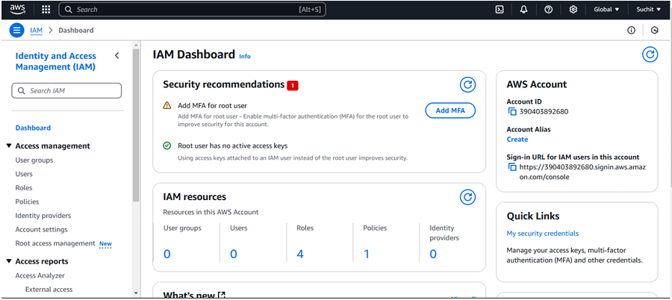

STEP 2 : CLICK ON ADD USER AND CREATE NEW USER.

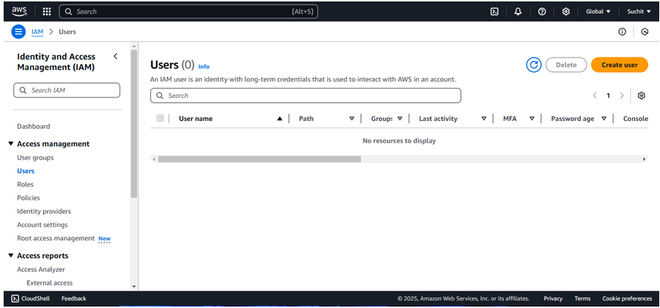

STEP 3 : CLICK ON CREATE USER.

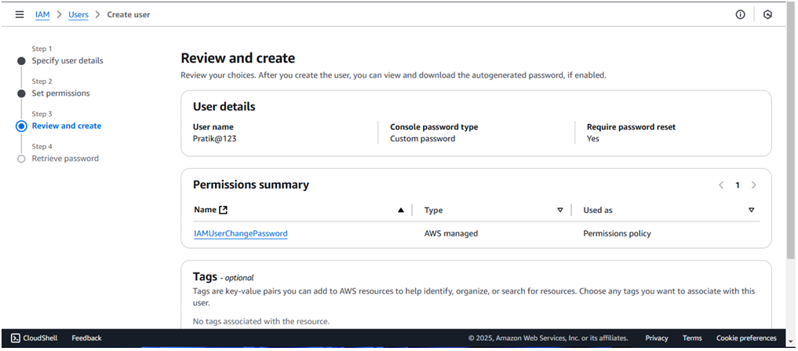

STEP 4 : SAVE THE ID AND DOWNLOAD THE CSV.

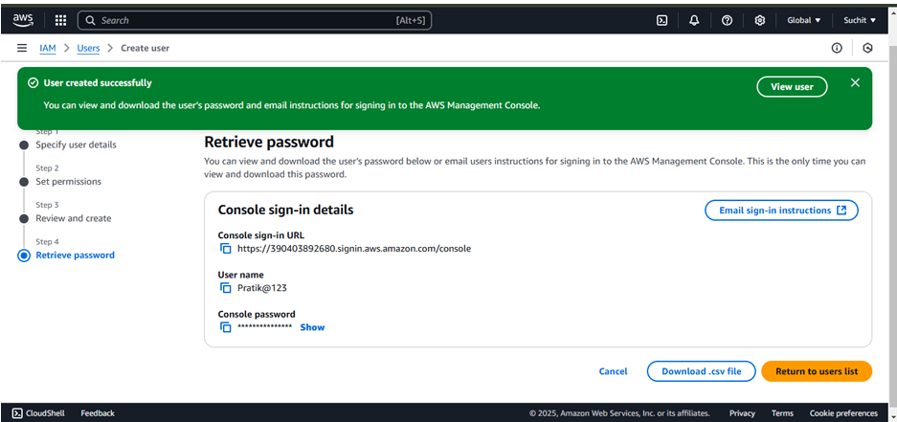

STEP 5 : LOGIN USING NEW USERNAME.

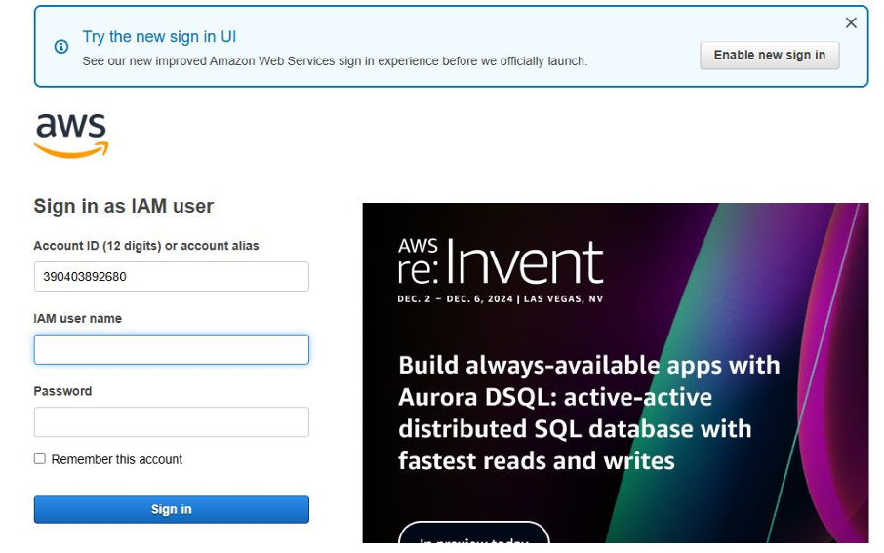

STEP 6 : AFTER LOGIN GO TO AWS COMMAND LINE INTERFACE CLICK ON FINISH.

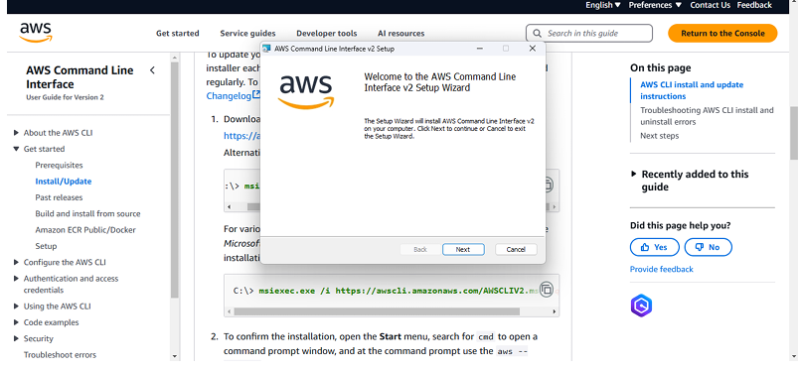

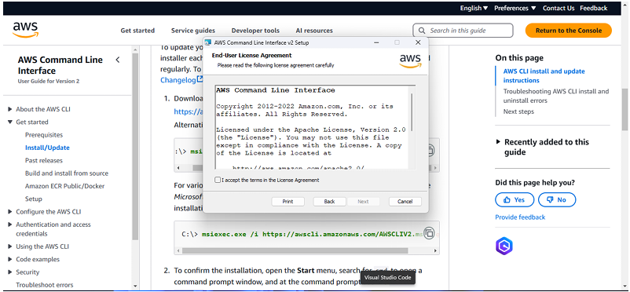

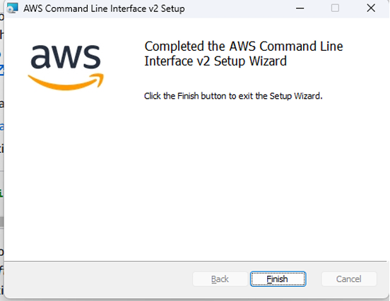

STEP 7 : AGAIN LOGIN AS A NEW USER.

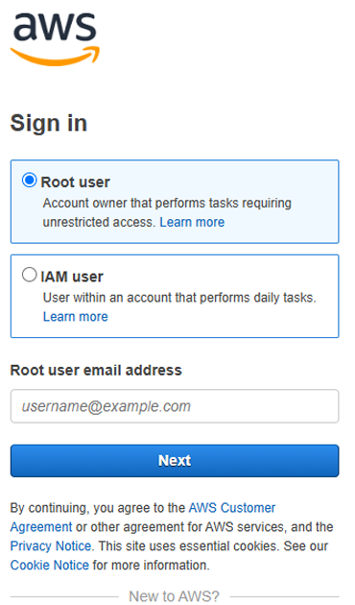

STEP 8 : GOTO USER AND CLICK ON CREATE NEW USER FROM WHERE YOU CAN CONTROL THE USERS.

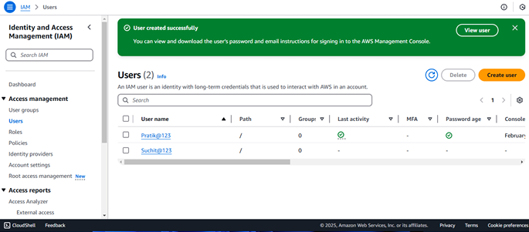

STEP 9 : CREATE NEW USER AND TRY WITH NEW USER IN ORDER TO CHECK I AM.

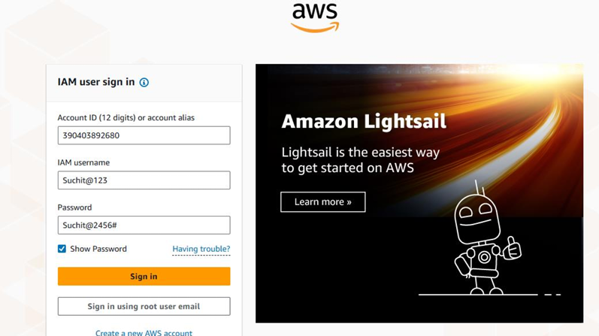

STEP 10 : DELETE THE BUCKET WHEN THE WORK IS DONE.

